Entrepreneurship in Vermicompost production for better income and livelihood
Dr Sharvan Kumar Yadav

Introduction: An entrepreneurship in the field of vermicomposting was developed which followed a process of idea, product initiation technology standardisation identification of business opportunity & marketing strategies, Dr. Sharvan Kumar Yadav after doing Ph.D. explored the academic & business opportunity from belong to Village-Sunderpura, Tehsil- Kishangargh Renwal, District-Jaipur, Rajasthan. During covid-19 pandemic, when everything was closed, he started an agri-business activity to utilize experience in Organic farming, I analysed that there is a huge demand of vermicompost, so I decided to open a vermicompost production unit.
Methodology:
During my M.Sc. and Ph.D. programme, I learned practical aspects about different organic inputs under mentorship of Dr S K Sharma, Director Research, MPUAT, Udaipur and worked as Senior Research Fellow in ICAR-All India Network Project on Organic Farming, MPUAT, Udaipur for six years, where I involved in many training programmes and learned scientific knowledge about methodology and application/utilisation of all organic inputs and got the idea at this centre. In initial phase, I started business with 17 vermibed with the size of 30 ft x 4 ft x 1.5 ft (each bed).
Results:
In beginning I faced social and economic constraints, but now I have 1000 vermicompost vermibeds. I am using social platform like You Tube, Facebook, Telegram, Instagram, Media and Newspaper for marketing of vermicompost, vermiwash and earthworm. I have my own You Tube channel named “Dr Organic Farming जैविक खेती” where I have uploaded more than 200 hundred videos which are informative and understandable for farmers. My You Tube channel is subscribed by 25000 and viewed by 3 million persons. My success story has been published in Danik Bhaskar, Rajasthan Patrika, Aaj Tak News, The Better India, New 24, Gujrat Samachar, India Times Hindi, Amar Ujala, Hello Kisan, Farm and Food Magazine, Haldhar Times etc.
My unit provide best quality vermicompost, vermiwash and earthworm to farmers. I give about 2000 to 2500 earthworm to farmers in 1 kg and if a farmer takes earthworm from somewhere else, he gets only about 300 to 400 earthworms in a kg. My contact number is 7976996775.

Impact:
I provided employment to nine persons per year from my village. My father was awarded The Best Organic Farmer at District level in Jaipur district in 2021 by the Hon'ble Agriculture Minister, Rajasthan Government and Hon'ble Vice-Chancellor of Sri Karan Narendra Agricultural University, Jobner, (Raj). My father was also awarded State Level Best Organic Farmer in Rajasthan state by the Hon’ble Chief Minister, Rajasthan Government. My farm annual turnover is Rs. 25 lakhs.
Message to farmers: Plan purposefully on your idea and pursue to achieve your goals with quality of your business and work.
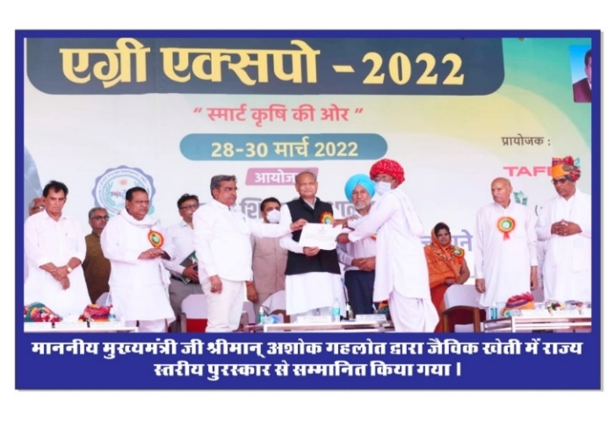 | 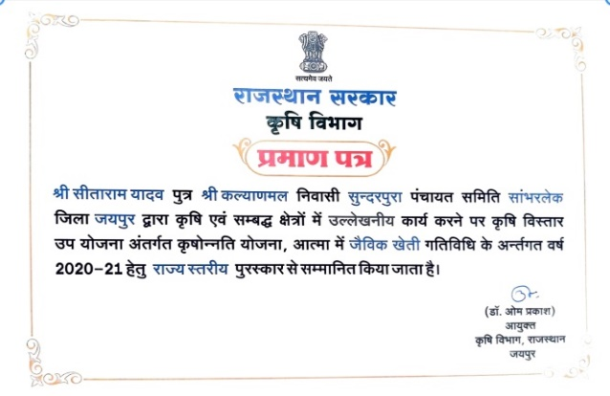
My father awarded Best organic farmer in Rajasthan State by Hon ‘able Chief Minister, Shri Ashok Gehlot ji | Best organic farmer Award in Rajasthan State
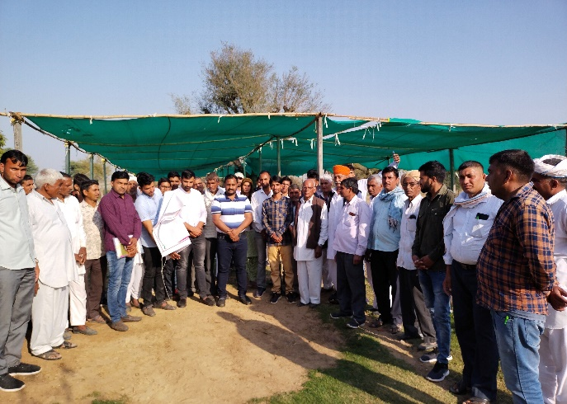 | 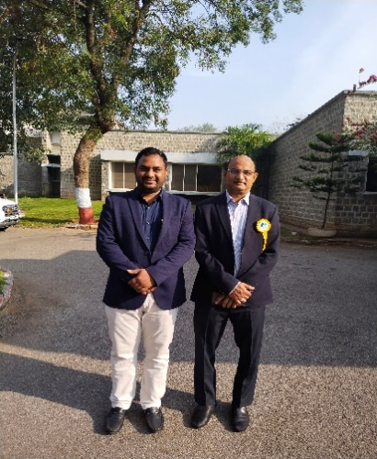
Free training to all Indian farmers | Me & My mentor Dr Shanti Kumar Sharma, Director Research, MPUAT, Udaipur
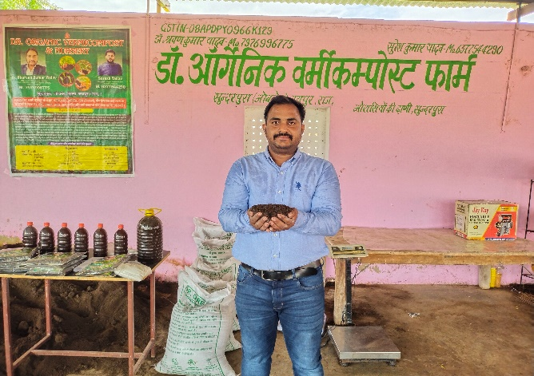 | 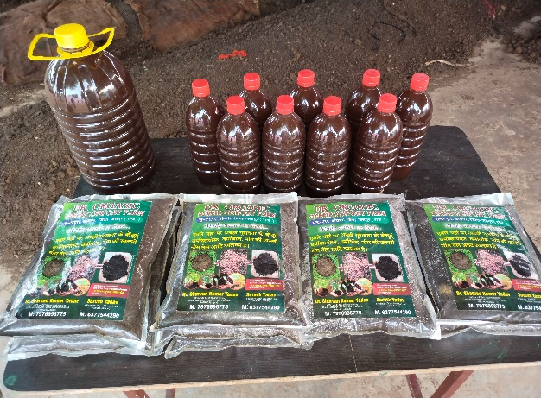
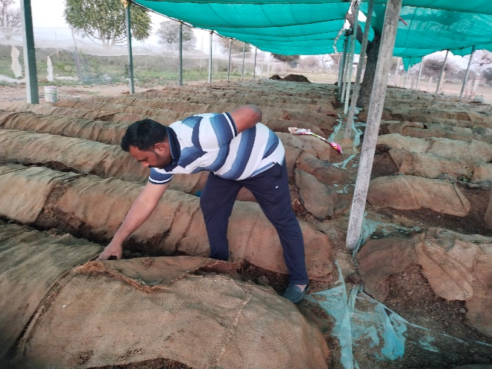 | 