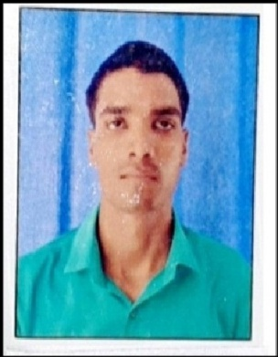

**Present Address:**

Village + Post Baibaha District Lakhimpur Kheri U.P

**Tejpal verma**

**M.Sc(Ag) Agronomy**

Contact No. 8948490101

E-Mail_ pateltpverma2512@gmail.com

**CAREER OBJECTIVE**

To work in a firm with a professional work driven environment where I can utilize and apply my knowledge, skills which would enable me as a fresh graduate to grow while fulfilling organizational goals.

B**ASIC ACADEMIC CREDENTIALS**

|  |  |  |  |
| --- | --- | --- | --- |
| **Qualification** | **Board/University** | **Year** | **Percentage** |
| **M.Sc.(Ag.)** | **CCSU MEERUT UP** | **2017-19** | **71.29 %** |
| B.Sc (Ag) | CSJM KANPUR UP | 2013-17 | 73.73 % |
| Senior Secondary Education | UP. BOARD | 2013 | 68 % |
| Higher Secondary Education | UP.BOARD | 2010 | 52.33 % |

**EXPERIENCE**

* Three years as a supervisor in Sambodhi Reasearch and communication pvt ltd

**IT PROFICIENCY**

* Microsoft Office Word, Microsoft Office Excel, Microsoft Office Power Point, MS Dos.
* 2 Year NSS Certificate
* Internet Browsing

**INTERPERSONAL SKILL**

* + Ability to rapidly build relationship and set up trust.
  + Confident and Determined.
  + Ability to cope up with different situations.

**PERSONAL DETAILS**

* **Father’s Name :- Mr. Harishankar Verma**
* **Permanent Address :-** Village + Post Baibaha District Lakhimpur Kheri U.P
* **Date of Birth :-** 25/12/1994
* **Language Known :-** English & Hindi
* **Marital Status :-** Single
* **Nationality/Religion :-** Indian / Hindu
* **Interest & Hobbies :-** Internet browsing , Reading Books, Social Media

**DECLARATION**

I do hereby declare that the above information is true to the best of my knowledge**.**

**Place: Tejpal Verma**

**Date:**