**Resume** 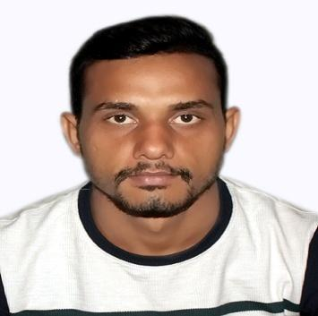

**Ankit Singh**

**Permanent Address**

Village –Mohammadpur Gujjar

Post - Titron

Tehsil – Nakur

Distt. - Saharanpur

Pin. - 247343 (UP)

Mobile No: 8439467579

Email Id. - [singhanki523@gmail.com](mailto:singhanki523@gmail.com)



**CAREER OBJECTIVE**

To work with a challenging environment in an organization that provides excellent work culture and paves

the way for early assumption of responsibilities. I also want to be asset the company I work for.

**WORK EXPERIENCE**

1. 1 year experience in **Patanjli** **Bio Research Institute Pvt. Ltd. Company, Haridwar (UK)249405. as a Filed Kashipur Uk.**
2. 2 year experience as the sales officer **Shree Ram Solvent Extraction Pvt.**

**Ltd. Company, Juspur (UK) Udham Singh Nagar 244712.**

1. **1 year experience in, Neuglobal upjvardhak india Limited (Kanpur UP) 208001.as a sales officer district Saharanpur.**
2. **1 year experience as a sales Executive in district Saharanpur .Laford Agritech Limited Company Gujarat India.364001**
3. **Currently working Kay bee bio organic Pvt .Ltd company (Pune Maharashtra**

**EDUCATION QUALIFICATION**

| | **S.R.**  **No** | **Education Qualification** | **Board/University** | **Percentage** | **Year** | | --- | --- | --- | --- | --- | | **1** | High School | **U.P. Board** | 48.67 | 2010 | | **2** | Intermediate | **U.P. Board** | 65.80 | 2012 | | **3** | B.Sc. (Agriculture) | **CH. Charan Singh University, Meerut** | 56.39 | 2017 | |
| --- | --- | --- | --- | --- | --- | --- | --- | --- | --- | --- | --- | --- | --- | --- | --- | --- | --- | --- | --- | --- |

**PERSIONAL DEATIAL**

* **Name**  : Ankit Singh
* **Date of Birth**  : April 06th, 1995
* **Father’s Name** : Randheer Singh
* **Gender** : Male
* **Marital Status** : Unarried
* **Nationality** : Indian
* **Hobbies :** Playing Cricket and Reading Books.
* **Language**  **:**  Hindi & English

**I hereby affirm and declare that the information given above by me is correct to the best of my knowledge**

**and belief.**

Signature

**Place: SAHARANPUR Ankit Singh**